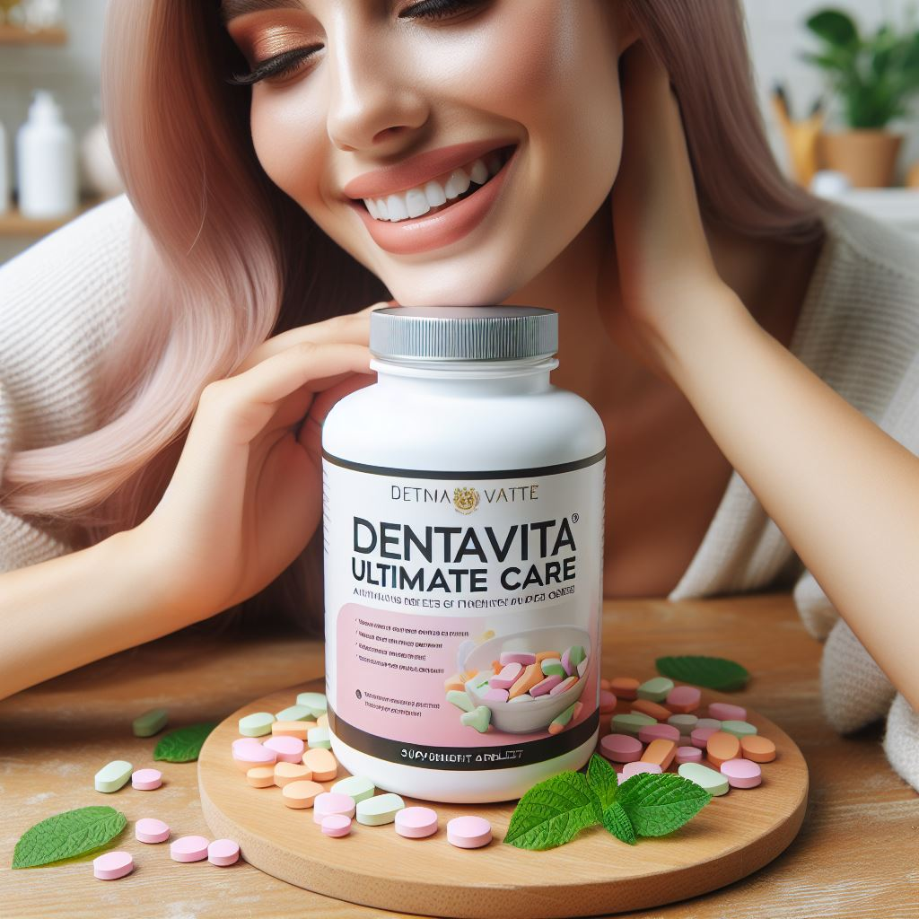

**DentaVita Ultimate care**

***Dental product***

**Group members:** Viktoria Kovacheva, Princia Nizigiyimana, Niloofar Ahmadpanah, Adeleh Borzouei, Muhammad Faiq, Paul Iheke, Lakshmi Narayan, Sandhya Repaka

**Abstract**

In the UK, where the cost of dental treatment is skyrocketing, Group 13 has designed an exceptionally powerful dental care product to provide a more cost-effective and accessible solution for dental protection; named “DentaVita Ultimate care”. It is a novel oral health formulation which incorporates some proven bioactive ingredients, such as sublingual vitamin D, lactoferrin, postbiotics, and catechin, in a highly effective but balanced fashion. The postbiotics in it, which are sourced from specific deactivated bacteria, help to preserve the balance of the oral microbiota and general oral health without possible side effects of using alive bacteria in the form of prebiotics. Afterwards, strong antioxidant called catechin sourced from green tea, offers anti-inflammatory and antibacterial effects as an additional shield against dental issues. Multifunctional protein lactoferrin which is widely distributed in saliva and plays a role in immunological regulation adds more power to antibacterial defence in the oral cavity. Finally, the addition of sublingual vitamin D supplementation targets to enhance immune system function, boost bone metabolism, and maximize oral health. All together these active ingredients create a complete oral care solution with the foremost needed oral health outcomes, such as decreased susceptibility to periodontal disease, increased enamel strength, and overall improved oral hygiene. It all comes with an easy to comply delivery in the form of flavourful mints. The current report provides details of objectives, literature review, methodology, business modelling, and funds needed to shape current idea into a profitable patent formulation with a handsome share for investors and researchers both. A need for smartly designed cross promotional business model and leverage based bargaining strategy was recognised for successful implementation of preliminary plan. Despite it entailed for a huge initial investment, the project: DentaVita ultimate care was found to be a viable and profitable venture with potential to change dynamics of oral health care market.

**TABLE OF CONTENTS**

Cover Page

Abstract 2

Table of Contents 3

1.0 Background 5

1.1 Aim and Objectives 5

2.0 Planning tools and framework models 6

2.1 SWOT Analysis 6

2.2 PESTLE Analysis 8

2.3 Porter’s Five Forces 10

3.0 Literature review 10

3.1 Postbiotics 11

3.2 Catechin 15

3.3 Vitamin D 16

3.4 Lactoferrin 18

4.0 Methodology 20

4.1 Postbiotic production 20

4.2 Extraction of EGCG from catechin 21

4.3 Vitamin D production 22

4.4 Lactoferrin production 22

4.5 Safety 23

4.6 Difficulties 23

5.0 Business Plan 24

5.1 Business Description 24

5.2 Market Analysis 24

5.3 Product Offering 25

5.4 Product affordability 25

5.5 Marketing and Sales Strategy 25

5.6 Funding Plan 26

5.7 Research and Development 26

5.8 Regulatory Compliance 27

6.0 Sell in Phases Strategy 27

7.0 Side project 29

7.1 Public Surveys 29

7.2 Cross-promotional business model 30

7.3 Financial strategy 30

8.0 Cost Estimates 31

9.0 Discussion 32

10.0 Conclusion 33

*References* 35

**1.0 Background**

In the UK, dental treatment through the NHS is generally more affordable for patients, but the wait times for new patients have become more extensive, often spanning months or even years as of 2024 (Mahase, 2024). Alternatively, private dentistry care is readily available, but more costly than NHS care. This makes it difficult for many to afford essential dental care especially given the recent increase in the cost of living (Meadows et al., 2024). Common treatments include dental cleaning, fillings, root canal treatments, extractions, and cosmetic procedures (Hollins, 2024). While mouthwash and toothpaste are commonly used, their effectiveness is limited when used alone, especially without added professional dental care (Hodge, 2016). Dentavita Ultimate Care introduces a potent new formula designed to elevate oral hygiene beyond the benefits of using toothpaste and mouthwash individually. The main ingredients of the product are lactoferrin, postbiotics, catechin, and sublingual vitamin D. Lactoferrin, a versatile protein abundant in dairy products, effectively fights oral pathogens and bolsters the body's immune response against oral infections with its antibacterial, antiviral, and immunomodulatory attributes (Wakabayashi et al., 2006). Additionally, postbiotics, metabolic byproducts of probiotic bacteria, enhance dental health by supporting beneficial bacteria growth and inhibiting harmful pathogens (Żółkiewicz et al., 2020). Catechin, a compound found in green tea, inhibits plaque bacteria and reduces gum inflammation, promoting oral hygiene (Ganeshpurkar & Saluja, 2020). Thus, offering a convenient solution also enhanced with Vitamin D, particularly beneficial in regions like the UK with limited sunlight exposure (Webb et al., 2010). Due to rising consumer desire for natural and practical oral care products, dental mints enhanced with postbiotics, catechin, lactoferrin, and sublingual vitamin D have a substantial market potential (Barnes, 2003; Septiani et al., 2022). These creative dental mints appeal to consumers who are concerned about their health and are looking for easy-to-use ways to boost overall wellness and preserve good oral hygiene!

**1.1 Aim and Objectives**

**Aim:** Creating a dental product that enhances oral health, prevents cavities, and addresses common dental issues by blending natural ingredients with postbiotics, known for improving gut health as well, while remaining significantly more cost-effective than professional dental care.

**Objectives:**

|  |  |
| --- | --- |
| **S** | Dental product, which affordably improves our oral health at home |
| **M** | Combination treatment |
| **A** | Combination treatment with well researched natural ingredients |
| **R** | Affordable and suitable for wide age range, decreases professional care visits; Costumers will prefer to pay the price for this product over paying every now and then for private dental treatments. Profitability! |
| **T** | Time required: 6-8 months |

**2.0 Planning tools and framework models**

To predict actual potential and feasibility of our business pitch different analytic models were applied i.e. SWOT analysis, Porters’s Five Forces, and PESTLE analysis. Application of these analytic models could provide valuable insights to shape business framework. Details and outcomes of each model are provided below.

**2.1 SWOT Analysis**

* **S: Strengths**

1. The strongest side of our idea is its novelty, as there is no such powerful formula available to fight against dental issues. When we say Dentavita Ultimate care, we talk about a dental care product which is “actually “effective and gives desired results.
2. All active ingredients are already proven to be effective in available literature and critical data linked with it, like their safe dose for human consumption and side effects.
3. Although our formula mainly focuses on dental care, it also offers added value by offering various other health benefits.
4. Our flavorful and easy-to-use mints stand apart from over-the-counter toothpastes and mouthwashes.

* **W: Weaknesses**

1. Dentavita Ultimate care is a new formula and not publicly proven as effective as it is claimed to be.
2. Public response towards it is uncertain.
3. Convincing respective industries and investors to buy our formula could be challenging.

* **O: Opportunities**

1. The increasing expenses of private dental care and long waiting list within the NHS are causing concern among people in the UK (Steele, 2024).
2. Following the new oral care market trends, dental care companies are already looking for consumable products to reduce the need of using traditional toothpastes (Seven trends, 2021).
3. Positive trend in oral care market growth (Figure. 1) could be helpful to gain investors’ trust.

* **T: Threats**

1. Intellectual property infringement or Idea theft.
2. Scientific and technological advancement i.e. nano dentistry.

**Figure 1:** Trend of UK oral care market showing continuous increase in investment from 0.31 to 0.44 billion USD. With same progression it is projected to reach 0.64 billion USD in next five years (Source: Oral care, 2024).

**2.2 PESTLE Analysis**

* **P: Political Factors**

There are no political factors associated with the current business proposal.

* **E: Economic factors**

Current business pitch is associated with multiple economic factors including rising costs of dental treatments (and overall inflation) in UK, marketing cost, new oral market trends of UK, and increase in investment on oral care.

* **S: Social Factors:**

Currently, there are no social factors that shape customer behavior in context of current product.

* **T: Technological Factors:**

Scientific advancements are a possible threat to our proposed formulation i.e. Nanoparticle based toothpaste, dental care products, and nano dentistry.

* **L: Legal Factors:**Advice must be taken from the medicines and healthcare products regulatory agency (MRHA). If the product is determined to have medicinal properties, it will follow the Human Medicines Regulations 2012 [SI 2012/1916] (“the Regulations”) guidance. A medicinal product will also require a marketing authorization (MA), traditional herbal registration (THR) or certificate of registration as a homoeopathic product granted by the European Commission or by the UK Licensing Authority. This is subject to the product meeting safety, efficacy and quality requirements imposed by the law. (Gov.uk, 2023). The product should follow the General Product Safety Regulations 2005, which ensure the safety of the products marketed subject to set requirements and UK Law. Finally, to ensure that the safety profile of the product is met animal testing and human clinical trials should be considered. The trials would follow the current legislations governing them including: the animal (scientific procedures) Act 1986 (GOV.UK, 2014) and the human use and regulations 2004 (legislation.gov.uk, 2004).
* **E: Environmental/ Ethical Factors:**

The proposed business pitch does not offer any direct threats to the environment. However, offering mints in biodegradable plastic packaging, could be helpful to reduce plastic waste contribution from empty toothpaste bottles. Our product may not be suitable for vegetarians, vegans, or animal activists as it contains animal-derived ingredients. The use of lanolin from sheep and fish liver oil for vitamin D production raises ethical considerations regarding animal welfare. Furthermore, animal testing and human clinical trials, that are recommended for the completion of the product’s safety profile, raise ethical considerations as well.

**2.3 Porter’s Five Forces**

* **Threat of New entrants:** There are “High entry barriers”, because devising a unique, effective, and feasible idea in dental care is inherently challenging.
* **Competitive Rivalry:** Although there are a few small companies offering unique dental products i.e. Dente91 toothpaste with lactoferrin, critically designed formulation of Dentavita Ultimate care stand above all others. So, the competitive rivalry is moderate.
* **Threat of substitutes:** Some of the active ingredients of Dentavita Ultimate care are naturally present in green tea or milk and commercially available probiotics. Nonetheless, our carefully formulated product offers the best combination of more than 5 active ingredients in the form of mints, which makes it an extremely effective and user-friendly product. It means that the threat of substitutes is also moderate.
* **Bargaining power of Buyers:** It is estimated that Dentavita Ultimate care shall cost more than any regular dental care product (which is against the buyers’ expectations), but in the long term it shall end up as a cost-effective solution to common dental issues. Furthermore, added value due to its extra benefits could be helpful to persuade buyers to buy it with a higher price tag. Overall, the bargaining power of buyers is high at this stage, which could be brought down by good marketing strategies, branding, and awareness.

* **Bargaining power of suppliers:**Due to the unique nature of the formulation, there are no other suppliers offering a similar product, which means the bargaining power of other suppliers is low at this stage.

**3.0 Literature review**

It is widely acknowledged, based on numerous studies, that the composition of oral microbiota plays a crucial role in oral health. Using whole metagenome sequencing methods, it has been determined that bacteria such as *Actinobacteria*, *Proteobacteria, Fusobacteria, Bacteroidetes,* and *Firmicutes* constitute about 80-95% of the total oral microbiome ([Ahn et al., 2011;](https://www.ncbi.nlm.nih.gov/pmc/articles/PMC10031100/) [Bik et al., 2010](https://www.ncbi.nlm.nih.gov/pmc/articles/PMC10031100/)). Tooth decay is the erosion of tooth surfaces due to bacterial plaque buildup, resulting in mineral loss from the crown and root (Gupta & Gupta, 2015). While numerous factors contribute to tooth decay, microbiological elements emerge as the predominant catalyst (Mosaddad et al., 2019). Therefore, bacteriotherapy is considered promising approach for the prevention of oral diseases (Fernández et al., 2010; Gruner et al., 2016; Laleman et al., 2015). Within the context of oral microbiota, *S. mutans* is identified as a fundamental factor in the occurrence of dental decay and is acknowledged for its capacity to form biofilms (Abd & Ali, 2016).

Ensuring proper oral hygiene is essential for managing both oral and systemic diseases by averting the formation, buildup, and expansion of dental plaque (Pihlstrom et al., 2005). Currently, primary plaque control involves mechanical devices (such as brushing, dental flossing, and interdental brushes); however, this alone is often inefficient (Sälzer et al., 2015). Consequently, chemical agents are frequently used to support plaque control as well, including topical antibiotics, chlorhexidine, povidone-iodine, xylitol, fluoride, and others (Serrano et al., 2015). Nevertheless, side effects associated with these agents have been reported, including unpleasant taste, tooth staining, tooth sensitivity, irritation, and painful mouth ulcers (Serrano et al., 2015).

The natural active ingredients of Dentavita Ultimate care have enhanced antimicrobial activity against *S. Mutans* and other cariogenic bacteria within the oral microbiota. The product provides a gentle and flavourful dental care option in the form of a mint, eliminating the need for mechanical devices and potential friction during oral care routines. The following literature review aims to explore the individual qualities of each of the ingredients used, their mode of action, as well as their extraction and manufacturing methods. The disadvantages and ethical concerns of their use are also discussed.

**3.1 Postbiotics**

Postbiotics, which utilize either the metabolic byproducts or the non-living components they produce, present an innovative and feasible solution for maintaining the oral health (Rad et al., 2023). *Lactobacillus*, a symbiotic microorganism existing in the human oral microbiota, impact significantly *Streptococcus* bacteria within the oral environment (Zhang et al., 2020). A study by Zhao was used as a reference in this review (Zhao et al., 2023). In this study, the potential of *L. paracasei* ET-22 to prevent dental caries was investigated by observing its impact on *S. mutans* biofilms (Zhao et al., 2023). The experiment simulated the oral environment, using an artificial saliva medium supplemented with 1% sucrose to culture *S. mutans* (Zhao et al., 2023). Following a 24-hour co-culture, the live bacteria and secretions of *L. paracasei* ET-22 demonstrated notable inhibitory effects on the formation of *S. mutans* biofilms (Zhao et al., 2023). Further, the single pathogen *S. mutans* (Model) was cultured separately as a control (Zhao et al., 2023). Following a 24-hour co-culture with *S. mutans*, ET-22-S groups showed decreased crystal violet staining readings (p < 0.01, Figure 1) (Zhao et al., 2023).

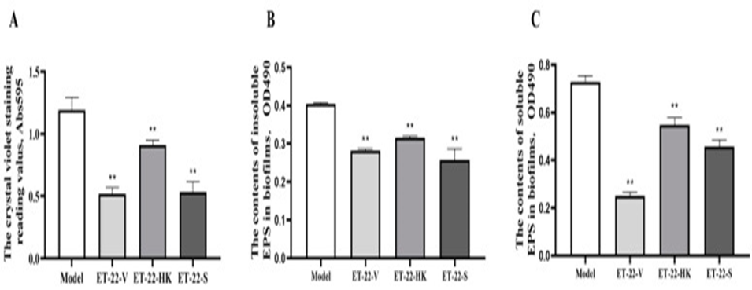

**Figure 1.** The figure shows the effects of live bacteria (ET-22-V), heat-killed bacteria (ET-22-HK), and secretions (ET-22-S) of *L. paracasei* ET-22 on the formation levels of *S. mutans* biofilms. Further, the figure demonstrates the impact of the components on the contents of insoluble extracellular polysaccharides (EPS) and soluble EPS in *S. mutans* biofilms. The control group consisted of the single pathogen *S. mutans* (Model). Significant differences were observed (** p < 0.01) compared to the Model group in all experiments (Zhao et al., 2023).

Additionally, this study examined the effects of *L. paracasei* ET-22 on the thickness and biomasses of *S. mutans* biofilms (Figure 2) (Zhao et al., 2023).

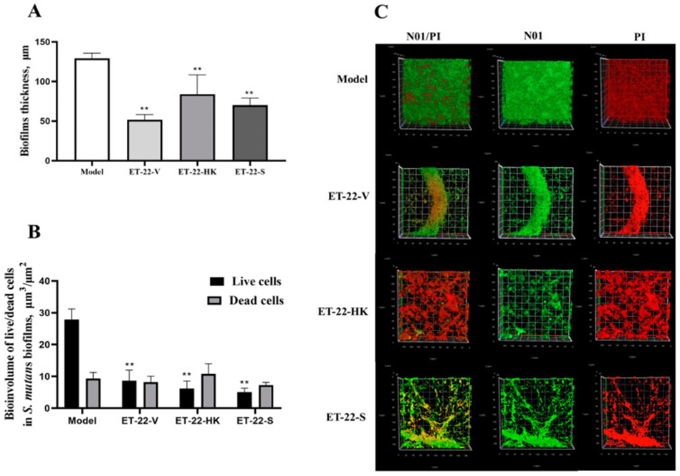

**Figure 2.** The figure shows the effects of *L. paracasei* ET-22 on the thickness and biomasses of *S. mutans* biofilms. (A) Alterations in the thickness of *S. mutans* biofilms following co-culture with live bacteria (ET-22-V), heat-killed bacteria (ET-22-HK), and secretions (ET-22-S) of *L. paracasei* ET-22 are examined. (B) Staining outcomes illustrating live and dead bacteria within *S. mutans* biofilms using confocal laser scanning microscopy. (C) Quantification of live bacteria (green) and dead bacteria (red) in *S. mutans* biofilms of the ET-22-V, ET-22-HK, and ET-22-S groups (Zhao et al., 2023).

In conclusion, based on this study, the postbiotic derived from *L. paracasei* ET-22 can significantly decrease *S. mutans* biofilm formation.

**3.1.1 Reducing *S. mutans* Presence: Mechanisms of Action using Postbiotic**

**A) Live *L. paracasei* ET-22 and its Postbiotics Inhibit the Formation of S. mutans Biofilms by Blocking the Initial Adhesion.**

*S. mutans* adheres to tooth surfaces, initiating biofilm formation (Zhao et al., 2023). The study indicates that *L. paracasei* ET-22 and its postbiotics reduce the expression of SpaP protein in *S. mutans*, crucial for its initial tooth adhesion (Zhao et al., 2023). Consequently, fewer *S. mutans* can attach to teeth, mitigating biofilm formation and dental concerns (Zhao et al., 2023).

**B) Live *L. paracasei* ET-22 and Its Postbiotics Inhibit *S. mutans* Biofilms by Interfering with the QS System and the Expression of Virulence Factors.**

Acid production and tolerance play key roles in *S. mutans*' ability to induce dental caries (Zhao et al., 2023). The research showed that *L. paracasei* ET-22 and its secretions suppressed the expression of genes related to acid production (LDH) and acid tolerance (ffh, recA, and relA) in *S. mutans* (Zhao et al., 2023). This inhibition of key functions impedes *S. mutans* biofilm formation, potentially preventing dental caries (Zhao et al., 2023).

**C) The Inhibitory Effect of Live L. paracasei ET-22 and Its Postbiotics on S. mutans Biofilms Is Mediated by Multiple Components.**

Organic Acids: Numerous organic substances were identified, including organic acids, in both the bodies and postbiotics of *L. paracasei* ET-22 (Zhao et al., 2023). Certain organic acids, such as phenyllactic acid, have been shown to impede the formation of biofilms in different pathogenic bacteria by reducing the expression of genes that regulate the production and release of virulence factors and components essential for biofilm formation (Wasfi et al., 2018).

Phenyllactic Acid: Phenyllactic acid, present in both the postbiotics and secretions of *L. paracasei* ET-22, is recognized for its ability to hinder biofilm formation and disrupt the quorum sensing (QS) system in other bacteria. Therefore, suggests a potential role in inhibiting *S. mutans* biofilms (Vermilyea et al., 2019; Zhao et al., 2023).

N-undecanoylglycine: N-undecanoylglycine, another metabolite found in postbiotics, may stimulate oral mucosal immunity to inhibit the development of *S. mutans* and its biofilms (Xiong et al., 2022; Zhao et al.,2023).

**3.2 Catechin**

Catechins, a subgroup of flavonoids present in tea, particularly green tea, have been associated with several potential benefits for dental health care, such as:

1. Antibacterial: Inhibits bacteria like *Streptococcus mutans*, reducing decay and plaque (Tsai et al., 2008).

2. Antioxidant: Neutralizes free radicals, lowering oxidative stress in the mouth (Tsai et al., 2008).

3. Anti-inflammatory: May alleviate gum inflammation and aid in periodontal disease management (Tsai et al., 2008).

4. Erosion protection: Strengthens enamel, guarding against acidic erosion from foods and drinks (Tsai et al., 2008).

Additionally, to produce our dental product, Epigallocatechin gallate (EGCG) is suggested to be used. EGCG is a catechin, which is a type of natural phenol and antioxidant found in green tea (Bordenave et al., 2014). Catechin's antimicrobial properties are mainly influenced by the charge and structure of the specific molecule EGCG it targets (Sirk et al., 2009). Research indicates that EGCG can induce aggregation and decrease fluorescence in liposomes, especially those containing negatively charged lipids (Sirk et al., 2009). This suggests that catechins disrupt bacterial membranes.

**3.3 Vitamin D**

Vitamin D plays a crucial role in oral health. Furthermore, deficiency in vitamin D can lead to various issues, such as dental and gum problems (Rathee et al., 2012). Additionally, vitamin D may be associated with some oral diseases like oral cancer and osteonecrosis of the jaw (Rathee et al., 2012). Vitamin D is a steroid hormone, primarily obtained from sunlight exposure, but it can also be obtained through diet and dietary supplements (Rathee et al., 2012). The common name for vitamin D includes vitamin D2 and D3. While vitamin D2 is produced from ergosterol by yeast through UV radiation, vitamin D3 results from 7-dehydrocholesterol in lanolin through UV radiation (Figure. 3) (Rathee et al., 2012).

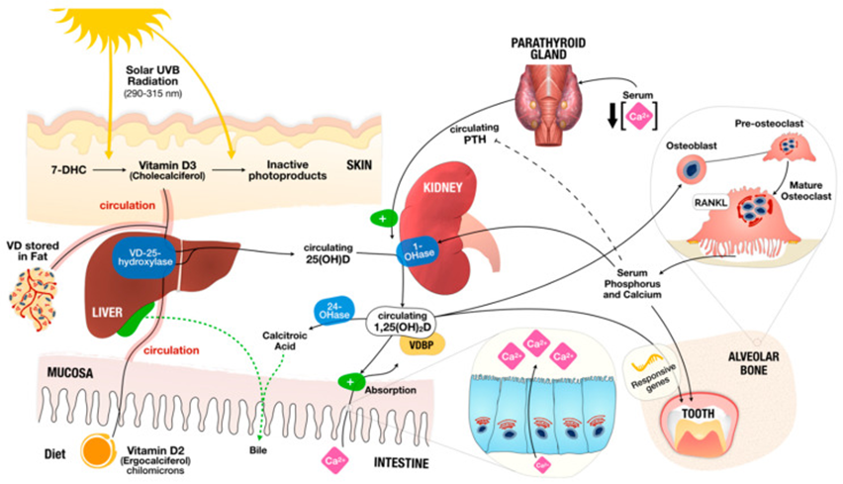

**Figure 3.** This figureshows how our body handles vitamin D and manages calcium, phosphorus, and bone health. We get vitamin D from sunlight (Vitamin D3) and food (Vitamin D2). When sunlight hits our skin, it turns a substance called 7-dehydrocholesterol into vitamin D3. Vitamin D from food gets absorbed into our bloodstream. In our liver, vitamin D becomes 25-hydroxyvitamin D (25(OH)D), which we use to check our vitamin D levels. Then, in our kidneys, it turns into an active form called 1,25-dihydroxyvitamin D (1,25(OH)2D). This active form helps regulate calcium and phosphorus levels by influencing how our body handles them. It also tells our bones to release calcium and phosphorus into our blood when needed. This process is important for maintaining strong bones and overall health.

Teeth consist of three hard tissues- enamel, dentin, and cementum, whose mineralization process occurs simultaneously with that of the bones (Rathee et al., 2012). Further, vitamin D plays a vital role in both bone and tooth mineralization (Rathee et al., 2012). Therefore, an imbalance in vitamin D levels can lead to "dental rickets," characterized by teeth that are inadequately mineralized and thus prone to damage and decay (Rathee et al., 2012). The main consequence of vitamin D deficiency is a drop in blood calcium and phosphate levels, prompting hyperactivity in the parathyroid glands (Rathee et al., 2012). This leads to increased calcium absorption in the intestines and vitamin D production, elevating blood calcium levels and lowering phosphate levels (Rathee et al., 2012). As a result, tooth mineralization is compromised, leading to irregularities (Rathee et al., 2012). Additionally, Vitamin D, via its receptors, influences gene expression and protein production crucial for dental structure. Genetic factors can contribute to vitamin D deficiency, impacting its metabolism and leading to dental tissue mineralization issues. This could increase the likelihood of dental issues or cavities, regardless of sufficient dietary intake or exposure to sunlight. (Mulligan et al., 2010).

**3.3.1 Vitamin D deficiency and periodontitis**

Periodontitis, a condition stemming from plaque buildup and characterized by persistent inflammation, is a widespread disease globally (Perić et al., 2018). The influence of dietary factors on gum health, particularly the deficiency of vitamin D, has been extensively studied. Furthermore, european experts have recently reached a consensus emphasizing the harmful effects of insufficient vitamin D levels on gum health and overall oral well-being (Perić et al., 2018).

Numerous cross-sectional studies have examined the correlation between vitamin D levels and periodontitis. However, the findings remain varied. While most studies suggest a link between lower vitamin D levels and periodontitis, some results indicate no discernible distinction. Moreover, higher concentrations of vitamin D have been associated with the reduction of periodontal issues, less severe forms of periodontitis, and fewer instances of tooth loss (Perić et al., 2018). In individuals without underlying health conditions, such as cardiovascular diseases and diabetes, lower levels of vitamin D have also been linked to the presence of periodontitis (Perić et al., 2018).

**3.4 Lactoferrin**

Lactoferrin (LF) is a glycoprotein that naturally occurs in saliva and mammalian milk, as it is secreted by exocrine glands (Kell et al., 2020). Additionally, it is found in the secondary granules of human neutrophils (Kell et al., 2020). Lactoferrin serves various functions in the body, including antimicrobial, antitumor, and anti-inflammatory roles (Abd El-Hack et al., 2023; Cao et al., 2023; Cutone et al., 2020).

In terms of oral health, lactoferrin plays a significant role in combating cariogenic bacteria like *Streptococcus mutans*, which is a major causative agent of caries and periodontitis (Loesche, 1986). It achieves this by binding to iron ions (Fe3+), depriving the bacteria of this essential nutrient and hindering their growth and virulence factor expression. (González-Chávez et al., 2009)

Moreover, lactoferrin influences the outer membrane of Gram-negative bacteria by interacting with lipopolysaccharides (LPS) (González-Chávez et al., 2009). The positively charged N-terminus of lactoferrin hinders the binding of LPS to bacterial cations (Ca2+ and Mg2+), resulting in the release of LPS from the cell wall (González-Chávez et al., 2009). This leads to heightened membrane permeability, causing damage to the bacteria. The interaction between lactoferrin and LPS also enhances the effectiveness of natural antibacterial agents like lysozyme, further inhibiting bacterial growth (González-Chávez et al., 2009). Lactoferrin is also effective against gram positive bacteria (Figure 4) (González-Chávez et al., 2009).

**Figure 4.** This figure shows the inhibitory mode of action of lactoferrin against Gram positive (A) and Gram negative (B) bacteria. Lactoferrin binds to the glycoprotein found on the external membrane of bacteria causing the release of the glycoprotein from the membrane surface, thus leading the formation of pores and destabilization of the bacterial membrane. This also permits lysozymes to further attack the bacterial cell wall by hydrolyzing it and eventually leading to the lysis of the bacteria.

Additionally, a clinical study conducted in thirty children with early childhood severe caries, has shown that using a toothpaste marketed under the brand name Bioextra, containing lactoferrin, lysozyme and lactoperoxidase had a positive and improved effect in reducing dental plaque, *S. mutans* and *L.acidopholus* bacteria count (Gudipaneni et al., 2014).

In summary, lactoferrin, postbiotics, catechin, and vitamin D have demonstrated effectiveness as antimicrobial agents and represent the ideal combination of ingredients in Dentavita Ultimate Care.

**4.0 Methodology**

**4.1 Postbiotic production**

To create this dental product, the initial step involves producing postbiotics as a key component. Below is the production process of postbiotics:

**Bacterial Culture:** *L. paracasei* ET-22 bacteria are initially cultured in a suitable medium, which provides essential nutrients for bacterial growth. The culture conditions, such as temperature, pH, and oxygen levels, are carefully controlled to optimise bacterial growth and metabolite production.

**Harvesting:** Once the bacteria have reached the desired growth stage, typically during the exponential growth phase, they are harvested from the culture medium. This can be achieved by centrifugation, filtration, or other separation techniques to separate the bacterial cells from the culture medium.

**Cell Disruption:** The harvested bacterial cells are then subjected to a process to disrupt their cell walls and release the intracellular compounds.

**Extraction of Postbiotics:** The disrupted bacterial cells are further processed to extract the desired postbiotic compounds. This extraction step typically involves solvents or chemicals to separate the target compounds from cell debris.

**Purification:** The extracted postbiotics undergo purification to remove impurities and concentrate the desired compounds. Purification methods include: Centrifugation, Dialysis, and Chromatography.

**Drying:** Finally, the purified postbiotics are dried to remove moisture and create a stable, powdered form. Common drying methods include:

1. Freeze-Drying (Lyophilization)**:** This involves freezing the postbiotic solution and then removing water under vacuum, resulting in a dry powder with minimal damage to the compounds.
2. Spray Drying**:** The postbiotic solution is atomized into fine droplets, which are then dried by hot air to produce a powdered form.

**4.1.1 Recommended dosage:**

Studies indicate that in individuals without cavities, the typical range of *S. mutans* in saliva falls between 10^4 and 10^5 CFU/mL (Deepti et al., 2008). However, when the concentration reaches 10^6 CFU/mL, the likelihood of developing cavities significantly rises (KLOCK & KRASSE, 1979). The recommended dosage of postbiotic to be used is 10^5 CFU/mL × 10 mL = 10^6 CFU.

**\*Based on theorised calculations found in the appendix (Deepti et al., 2008)**

**4.2 Extraction of EGCG from catechin**

The extraction of EGCG from catechin-rich sources such as green tea leaves entail a series of consecutive steps. It begins with the selection of an appropriate source, followed by the preparation of the raw material through grinding or crushing (Avadhani et al., 2017). Subsequently, various extraction techniques, including solvent extraction using ethanol or methanol, solid-liquid extraction, or supercritical fluid extraction with CO2, are utilized (Avadhani et al., 2017). After extraction, methods such as filtration or centrifugation are employed to isolate the crude extract containing EGCG (Avadhani et al., 2017). Following this, purification procedures involving chromatography are carried out to separate EGCG from other compounds found in the extract. (Avadhani et al., 2017). The presence and purity of EGCG in the final product are confirmed using analytical techniques, such as mass spectrometry or nuclear magnetic resonance spectroscopy (Avadhani et al., 2017). The purified EGCG is then stored under suitable conditions to maintain its stability (Avadhani et al., 2017).

**4.3 Vitamin D production**

In the laboratory production of vitamin D3 for a dental product, the process begins by obtaining a precursor compound such as 7-dehydrocholesterol (7-DHC) from sources like lanolin or fish liver oil (Kwok et al., 2013). The 7-DHC is then extracted or synthesized and converted into vitamin D3 through methods like UV irradiation or chemical activation (Kwok et al., 2013). Following this, the synthesized vitamin D3 undergoes purification to enhance its quality and concentration (Kwok et al., 2013). The purity and concentration of the purified vitamin D3 are analysed before it is formulated into the dental product (Kwok et al., 2013). Subsequently, the product undergoes testing to ensure its effectiveness and safety, and compliance with relevant regulatory authorities is ensured (Kwok et al., 2013).

**4.4 Lactoferrin production**

Lactoferrin is a protein extracted from ingredients such as skim milk or cheese whey. It is extracted through pasteurization under moderate temperatures as the protein is heat sensitive and can easily be denatured. This process is followed by milk microfiltration to remove any harmful bacteria from the product. Lactoferrin, is thereafter purified using techniques such as: ion exchange chromatography and membrane filtration. The final product is manufactured into a powder produced via freeze drying or gentle spray drying. (Gea, 2024)

**4.5 Safety**

Research outcomes from both controlled laboratory studies (in vitro) and studies conducted in living organisms (in vivo) indicate that postbiotics are safe for clinical application and demonstrate beneficial therapeutic effects when administered in appropriate quantities and duration (Dinić et al., 2017; Patel & Denning, 2013). Recent studies propose that postbiotics, derived from probiotics subjected to heat treatment, may offer a reliable and efficient method for maintaining gastrointestinal health (Maehata et al., 2021). Moreover, in their study, Homayouni Rad and colleagues emphasized that postbiotics, distinguished by attributes like safety, extended shelf life (up to 5 years), lack of toxicity, standardization, and simplified transportability, could present secure and economical substitutes for probiotics in both pharmaceutical and food sectors. (Homayouni Rad et al., 2021; Rad et al., 2021a)

**4.6 Difficulties**

Several studies suggest that the oral presence of *S. mutans* varies between 10^4 and 10^5 to 10^6. Maintaining this balance is essential, yet determining the precise daily intake for each person is complex due to factors like diet, carbohydrate consumption, and overall dental condition. Furthermore, persuading individuals to embrace a new alternative to brushing, a routine practice for many, could pose challenges. Since this product will be ingested, it is important to establish safe dosage thresholds, particularly for pregnant women, children, and individuals with specific medical conditions. Conducting trials to determine the appropriate dosage for these populations is necessary.

**5.0 Business Plan**

It is well known that oral health plays a vital role in the physical, mental, social, and economic well-being of individuals and populations (Peres *et al*. 2019). Dentavita Ultimate Care aims to revolutionize oral hygiene by producing a dental product in the form of a mint that combines natural ingredients and postbiotics to improve oral health and prevent common dental problems.  Our goal is to commercialize this product and make it available to a wide audience in UK by partnering, through mass production license sale, with top companies like GlaxoSmithKline (GSK), Johnson & Johnson, and Unilever. Named Dentavita Ultimate Care, this dental supplement offers an enhanced oral health formula with a combination of postbiotics, catechin, lactoferrin, vitamin D, calcium, and magnesium.

**5.1 Business Description**

Dentavita Ultimate Care is committed to producing a dental product that offers affordable and effective oral care at home. Our combination treatment utilizes well-researched natural ingredients to provide a comprehensive solution for oral health. By reducing the need for professional dental care visits, our product aims to be cost-effective and suitable for a wide age range of consumers. We anticipate high demand for Dentavita Ultimate Care, leading to profitability within 8-12 months.

**5.2 Market Analysis**

Tooth decay and gum disease are the most prevalent oral health issues worldwide (Ozdemir, 2013). According to a study conducted by the Centers for Disease Control and Prevention (CDC) in 2018, a high percentage of untreated teeth were found in people between the ages of 5 to 44 (Petti et al., 2018). Dental caries treatment can be costly and account for a significant portion of the total healthcare cost borne by developed nations (Kandelman et al., 2012). The FDI World Dental Federation highlights that young people are particularly affected, with the prevalence of dental caries ranging from 60% to 80% in developed countries throughout North America and Europe (Sampaio et al., 2021).

The increasing incidences of periodontal disease are fueling the growth of the oral care market (Watt et al., 2019). With a range of oral care products available in the market, it is crucial to select the most appropriate product for your oral care needs.  Overall, the increasing consumer awareness of oral health issues will continue to drive the growth of the oral care market in the coming years. Thus, consumers are seeking convenient and affordable solutions for maintaining their oral health at home. Dentavita Ultimate Care addresses this demand by offering a unique combination treatment that improves oral health while minimizing the need for costly professional care visits.

**5.3 Product Offering**

Dentavita Ultimate Care is a dental supplement in the form of a mint that promotes enhanced oral health. Our formula includes a vital combination of postbiotics, catechin, lactoferrin, vitamin D, calcium, and magnesium. This powerful blend of ingredients targets oral bacteria, strengthens tooth enamel, and supports overall health. Dentavita Ultimate Care is affordable, convenient, and suitable for individuals of all ages.

**5.4 Product affordability**

According to our smart calculations and estimations, our partner companies should be able to mass produce a single bottle/packaging of 60 dozes (1 daily) with landed cost of 15£. Considering if bottle is sold with reasonable profit margin of 10£, Dentavita Ultimate care with super efficacy against dental illnesses and multiple added health benefits will be an affordable option in the long term.

**5.5 Marketing and Sales Strategy**

To promote Dentavita Ultimate Care, we will employ a multi-faceted approach, including digital marketing, social media influencers, and partnerships with dental professionals. Emphasizing its effectiveness, affordability, and convenience, we will target our audience through tailored ads and promotions. Unlike mass promotions the low budget niche marketing shall only aim to our goal to secure partnerships with industry leaders like GSK and Unilever to expand market access. Through strategic negotiations and operational readiness, Dentavita will be positioned as a valuable addition to their portfolios, effectively addressing prevalent oral health issues. Our sale strategy is inspired by another successful startup of “Modern Meadows”. They initially introduced their next generation raw clothing materials through niche marketing and then successfully mass commercialized it by collaborating with some famous designers and brands.

**5.6 Funding Plan**

To fund the Research, development, and niche marketing of Dentavita Ultimate Care, we will pursue various sources of funding. Initially, we will seek seed funding through university entrepreneurship centers (University of Salford’s Launch Business Incubator), innovation grants (The Biotechnology and Biological Sciences Research Council), and crowdfunding platforms. These resources will provide the necessary capital to conduct market research, develop the product, and initiate marketing campaigns.

As the project progresses, we will explore additional funding opportunities, such as venture capital investment or strategic partnerships with industry players. Securing investment from top companies like GSK or Unilever would not only provide financial support but also lend credibility to our product and enhance our market value as a R&D company.

**5.7 Research and Development**

Research and development (R&D) will be a core focus of our project, as we continuously strive to improve and innovate our dental gummy product. We will allocate resources to conduct comprehensive research on natural ingredients, postbiotics, and oral health science to optimize the formulation of Dentavita Ultimate Care. Collaborating with university faculty and research centers, we will explore emerging technologies and scientific advancements to enhance the efficacy and safety of our product.  Consumer feedback from surveys and product testing will inform our R&D efforts, guiding further improvements and ensuring alignment with consumer preferences and needs.

**5.8 Regulatory Compliance**

Compliance with regulatory standards and certifications is essential for ensuring the safety and efficacy of Dentavita Ultimate Care. We will work closely with regulatory agencies, consultants, and legal advisors to navigate the complex landscape of food and dietary supplement regulations. Prior to market launch, we will conduct thorough testing and evaluation to ensure our product meets all regulatory requirements for quality, safety, and labeling.  Ongoing compliance monitoring and periodic audits will be implemented to maintain adherence to regulatory standards and mitigate any potential risks or liabilities.

**6.0 Sell in Phases Strategy**

**1. Market research and segmentation:** To comprehend the varied requirements and preferences of different customer segments, in-depth market research will be conducted. The market will be divided into segments according to criteria like age, income level, oral health requirements, and product preferences.

**2. Product Development:** An initial version of the dental product will be developed that targets the most common and urgent requirements of various customer groups. This product needs to be effective and user-friendly for a wide range of individuals i.e. in the form of gummy/mint.

**3. Phase 1 Launch:** With an emphasis on passing our concept to maximum people through niche marketing i.e. by installing camps in different concept expo, delivering lectures at available platforms, conducting public surveys, collaborating with influencers and bloggers.

**4. Collect Feedback:** Encourage customers to provide feedback and expectations about concept, assessing potential of product to succeed in public domain, bringing any required changes in formulation according to public drives i.e. flavours, gummies or mints, special formulations for different age groups etc.

**5. Iterate and Improve:** Make the required changes to the product to base on the feedback received.

**6. License pitch:** The mass production license shall be offered to through a leverage based bargaining strategy to different companies. The priority level of companies is shown in the table 1.

**7. Phase 2 Development:** Part of income from license fees will be used to develop the next version of the dental product by applying the variation in market demands with time. Customizing some features or variations to better meet the distinct needs of dynamic client segments.

**8. Phase 2 Launch:** Targeted/ Niche marketing campaigns will be once again to introduce our improved formulation to public.

**9. Repeat Steps 4-7:** To increase the product's impact, keep collecting feedback, make changes to the product, and introduce new phases. Marketing tactics and messaging should be modified to reflect the changing needs and preferences of the target audience.

**10. Marketing and Communication:** Using a variety of platforms, including social media, influencer partnerships, and educational content, successfully convey the advantages of the dental product to a broad spectrum of consumers. Tailor messaging to address specific concerns and motivations of different demographic groups.

**11. Monitor and Evaluate:** Continuously monitor sales performance, customer satisfaction, and market trends to assess the success of each phase and inform future strategies. Data-driven insights will be used to make informed decisions about product development and marketing efforts.

**Table 1.** Priority lists of our target companies for mass production license sale.

*List 1 represents our top priority and some of the biggest names in the field followed by List 2. List 3 are small-medium scale industries rapidly gaining market shares by offering products similar DentaVita Ultimate care.

|  |  |  |  |  |
| --- | --- | --- | --- | --- |
| **List 1** | Unilever | Johnson & Johnson | GSK | P&G |
| **List 2** | Forhans | Guard of life | Vitabiotics | Lifeplus |
| **List 3** | YUMI | Scudo | luvbiotics | bluem |

**7.0 Side project**

After subjecting our business idea to various analytical models, a few technical weaknesses were identified. One critical aspect was enhancing the attractiveness of our product to investors and potential partner companies. It was important for our product to have an upfront visible presence and established foundation in the public domain before licensing pitch. To address this issue, two suggestions were put forward by our team members i.e., conduction of public surveys and switching to a cross-promotional business model.

**7.1 Public Surveys**

To ensure our upcoming dental mint product meets consumer needs, we are planning a thorough survey. Objectives include assessing consumer awareness, preferences, and price sensitivity regarding dental mints. Additionally, we aim to gauge public opinion on the use of mints for dental care. The survey will feature sections on demographics, product awareness, preferences, and price sensitivity, with a mix of multiple-choice and open-ended questions. We will distribute the survey digitally through social media, email, and partnerships with dental professionals. Analysis of the collected data will guide our product development, marketing, and pricing strategies. The survey has been allocated a budget for survey design, distribution, and analysis. By gathering insights directly from our target audience and understanding public perception, we aim to create a dental gummy product that exceeds expectations and promotes healthy teeth for all.

**7.2 Cross-promotional business model**

As a cross-promotional business model, it was suggested to make a little side investment in making mobile games for promotional and educational purposes. The idea came from mobile games that were accessible on the Apple App Store and Play Store that dealt with animated stimulations of dental problems and treatment. These apps and games are quite popular; the most have received over 20 million downloads. Teeth Shield, Doctor Dentist, and Pet Dentist are three examples. By simplifying the mechanisms of action of our product in a layman-friendly manner and representing it in the form of unique mobile game, it can serve as a tool not only for educating people but also for promoting our product. Furthermore, by integrating the concept of a mobile game with public surveys and some projects of the University of Salford i.e., by collaborating with students of computer science or Phage modeling program run by Dr. Chaloe James, the goal could be achieved more economically. At the same time, a mobile game also has potential to turn up as a profitable venture independently.

**7.3 Financial strategy**

To fund the planned survey and develop mobile games, we intend to utilize the resources and support services available to students at the University of Salford. This includes leveraging entrepreneurship centers, mentorship programs, and innovation grants. We will seek guidance and assistance from faculty members, alumni, and industry mentors to secure funding and aid in the development of this aspect of the project.

Additionally, we plan to collaborate with students from the computer science department to develop mobile games. This collaboration aims to minimize development costs and make use of the existing resources within the university. By working with students who have expertise in game development, we can efficiently create engaging and educational mobile games to complement our project. Doing these would help us successfully execute the survey and mobile game development phases of our project.

**8.0 Cost Estimates**

**1.** Hiring market research firms or consultants (Master students): **£3,500 - £14,000**

**2.** Research and development costs, formulation expenses, testing, and compliance with regulatory standards: **£35,000 - £140,000**

**3.** Marketing materials, advertising campaigns, promotional events, and distribution channels, app development: **£7,000 - £35,000**

**4.** Conducting surveys, organizing focus groups, or implementing feedback collection systems (feedback collection): **£700 - £3,500**

**5.** Costs for product iteration (additional research and development, manufacturing updates and quality assurance testing): **£14,000 - £70,000**

**6.** Phase 2 development and launch (2,3): **£42,000 - £175,000**

**7.** If further phases required (2,3,4): **£42,700 - £178,500.**

**8.** Advertising, public relations, social media management, customer support operations for app, other promotional activities: **£3,500 - £14,000** per month

**9.** Scaling up production, distribution, and customer support operations (equipment, personnel, infrastructure, and technology upgrades): **£3,500 - £14,000** per month

**10.** Continuously monitoring sales performance, customer feedback, and market trends (analytics tools, data collection systems): **£700 - £3,500** per month

**11.** License under Patent Act1977 + renewals: **£500 - £1000**

* Total expenses for 2 Phases: **£102,200 – £437,500 + £7,700 – £31,500** monthly
* Total expenses for more than 2 Phases: + **£42,700 – £178,500** per Phase

**9.0 Discussion**

According to an investigation carried out by the Mirror journal, a staggering 11 million people were unable to obtain NHS dental appointments in 2022 in the UK, a number that has increased by 4 million in comparison to data collected in 2019 (Dubas-Fisher & Clements-Thrower, 2024). Additionally, the prices of private dentistry have risen over the years (Steele, 2024). Therefore, causing dental care to become unaffordable for most of the citizens, with other contributing factors, such as the rising cost of living. Dentavita ultimate care is theorized to have great potential in reducing the incidence of dental procedures, such as fillings and root canals, as the incidence of caries is expected to be dramatically reduced when the product is used regularly. Dentavita Ultimate care aims to provide affordable dental care for consumers while alleviating pressure on the NHS.

Moreover, recent studies have confirmed the individual effectiveness of the selected ingredients, which have been utilized separately in other dental formulations. As an example, Denta 91 is a currently marketed toothpaste that includes lactoferrin in its formula (Dente91, 2024). Furthermore, although not yet available commercially, studies have shown that a catechin mouthwash exhibits enhanced plaque reduction compared to a chlorhexidine gluconate mouthwash (Kaur et al., 2014). However, the effective concentration amount of the ingredients used in Dentavita Ultimate care remains to be determined. A product that has a maximal effect with an acceptable safety profile must be produced and tested prior to release.

Some ingredients will be extracted from animal sources. Thus, consumers preferring to consume an animal-free diet needs may not be met by the product. Therefore, it should be taken into consideration that Dentavita Ultimate care should use plant-based ingredients in its composition in the future. As an example, Jäpelt and Jakobsen have demonstrated in their review “Vitamin D in plants: a review of occurrence, analysis and biosynthesis” that microalgae contain a high source Vitamin D and could be possibly used as alternative to lanolin (Jäpelt & Jakobsen, 2013).

Overall, an estimated amount between £102,200 – £437,500 was requested to develop the product in two phases with an additional £7,700 – £31,500 requested monthly. Due to the uniqueness and newness of the product, fees for a patent license application were also included in the amounts requested. With a patent in place the inventors of Dentavita Ultimate care will remain assured that their invention will not be misused by competitors. Thus, protecting the product itself, the inventors and any investors of the product, from experiencing some economical loss. Additionally, the inventors could receive exclusive rights to profit from their invention and generate revenue through licensing agreements with other companies if GSK or Unilever prove not to be interested in the product.

**10.0 Conclusion**

In conclusion, Dentavita Ultimate Care represents a breakthrough in addressing the UK's expensive and lengthy dental care waiting times. Through rigorous analysis employing SWOT, Porter’s Five Forces, and PESTLE frameworks, the product emerges as a cost-effective and efficient solution to oral health challenges, meeting the demand for accessible dental care. Based on scientific findings, Bacteriotherapy stands out as a promising preventive approach. Dentavita incorporates a Postbiotic sourced from L. paracasei ET-22, displaying notable efficacy in inhibiting S. mutans biofilms. Furthermore, the product includes natural ingredients like catechins from green tea, vitamin D, and lactoferrin, each showcasing antimicrobial, mineralization-promoting, and protective qualities, respectively. Despite existing challenges in dosage determination, efficacy assessment, and ethical considerations, further research and ethical sourcing practices are imperative. Furthermore, prior to its release in the UK, seeking advice from the MHRA and ensuring compliance with EU directives and UK laws, including safety regulations, are essential steps. Finally, Dentavita Ultimate Care, a revolutionary dental supplement, aims to address prevalent dental issues with its natural ingredient blend. Through strategic partnerships, comprehensive market analysis, and innovative marketing strategies, the project endeavours to deliver affordable and effective oral care solutions.

**References:**

Abd El-Hack, M. E., Abdelnour, S. A., Kamal, M., Khafaga, A. F., Shakoori, A. M., Bagadood, R. M., Naffadi, H. M., Alyahyawi, A. Y., Khojah, H., Alghamdi, S., Jaremko, M., & Świątkiewicz, S. (2023a). Lactoferrin: Antimicrobial impacts, genomic guardian, therapeutic uses and clinical significance for humans and animals. *Biomedicine & Pharmacotherapy = Biomedecine & Pharmacotherapie*, *164*(114967), 114967. <https://doi.org/10.1016/j.biopha.2023.114967>

Abd, S. T., & Ali, A. F. (2016). The Effect of Zinc Oxide Nanoparticles on Streptococcus mutans of Human Saliva (In Vitro Study). *Journal of Baghdad College of Dentistry*, *28*(2), 158–164. <https://doi.org/10.0001/1164>

Adachi, S., Shimizu, M., Yohei Shirakami, Yamauchi, J., Hideo Natsume, Rie Matsushima-Nishiwaki, To, S., Weinstein, I. Bernard., Moriwaki, H., & Osamu Kozawa. (2009). (-)-Epigallocatechin gallate downregulates EGF receptor via phosphorylation at Ser1046/1047 by p38 MAPK in colon cancer cells. *Carcinogenesis*, *30*(9), 1544–1552. <https://doi.org/10.1093/carcin/bgp166>

Arakawa, H., Maeda, M., Okubo, S., & Shimamura, T. (2004). Role of Hydrogen Peroxide in Bactericidal Action of Catechin. *Biological & Pharmaceutical Bulletin*, *27*(3), 277–281. <https://doi.org/10.1248/bpb.27.277>

Avadhani, K. S., Manikkath, J., Tiwari, M., Chandrasekhar, M., Godavarthi, A., Vidya, S. M., Hariharapura, R. C., Kalthur, G., Udupa, N., & Mutalik, S. (2017). Skin delivery of epigallocatechin-3-gallate (EGCG) and hyaluronic acid loaded nano-transfersomes for antioxidant and anti-aging effects in UV radiation induced skin damage. *Drug Delivery*, *24*(1), 61–74. <https://doi.org/10.1080/10717544.2016.1228718>

Aziz Homayouni Rad, Hadi Pourjafar, & Esmaeel Mirzakhani. (2023). *A comprehensive review of the application of probiotics and postbiotics in oral health*. *13*. <https://doi.org/10.3389/fcimb.2023.1120995>

Balaky, H., & Alaa Taha Younis Al-Hammadi. (2021). A Identification and Isolation of Several Bacteria from oral cavity among human in Soran City. *Al-Qadisiyah Journal of Pure Science*, *26*(5), 1–7. <https://doi.org/10.29350/qjps.2021.26.5.1384>

Barnes, J. (2003). Pharmacovigilance of herbal medicines: a UK perspective. Drug Safety, 26, 829-851.

Bordenave, N., Hamaker, B. R., & Ferruzzi, M. G. (2014). Nature and consequences of non-covalent interactions between flavonoids and macronutrients in foods. *Food Funct.*, *5*(1), 18–34. <https://doi.org/10.1039/c3fo60263j>

Botelho, J., Machado, V., Proença, L., Delgado, A. S., & Mendes, J. J. (2020). Vitamin D Deficiency and Oral Health: A Comprehensive Review. *Nutrients*, *12*(5). <https://doi.org/10.3390/nu12051471>

Cao, X., Ren, Y., Lu, Q., Wang, K., Wu, Y., Wang, Y., Zhang, Y., Cui, X., Yang, Z., & Chen, Z. (2023a). Lactoferrin: A glycoprotein that plays an active role in human health. *Frontiers in Nutrition*, *9*(1018336.), 1018336. <https://doi.org/10.3389/fnut.2022.1018336>

Cutone, A., Rosa, L., Ianiro, G., Lepanto, M. S., Bonaccorsi di Patti, M. C., Valenti, P., & Musci, G. (2020b). Lactoferrin’s Anti-Cancer Properties: Safety, Selectivity, and Wide Range of Action. *Biomolecules*, *10*(3), 456. <https://doi.org/10.3390/biom10030456>

Deepti, A., Jeevarathan, J., Muthu, M., Rathna Prabhu, V., & LNU, C. (2008). Effect of Fluoride Varnish on Streptococcus mutans Count in Saliva of Caries Free Children Using Dentocult SM Strip Mutans Test: A Randomized Controlled Triple Blind Study. *International Journal of Clinical Pediatric Dentistry*, *1*(1), 1–9. <https://doi.org/10.5005/jp-journals-10005-1001>

Dente91. (2024). *Dente91 Lactoferrin Toothpaste*. DENTE91. <https://dente91.com/dente91-toothpaste/>

Dinić, M., Lukić, J., Djokić, J., Milenković, M., Strahinić, I., Golić, N., & Begović, J. (2017). Lactobacillus fermentum Postbiotic-induced Autophagy as Potential Approach for Treatment of Acetaminophen Hepatotoxicity. *Frontiers in Microbiology*, *8*, 594. <https://doi.org/10.3389/fmicb.2017.00594>

Dubas-Fisher, D., & Clements-Thrower, A. (2024, January 24). *Millions giving up on NHS dentist appointments - patient numbers in your area*. The Mirror. <https://www.mirror.co.uk/news/health/nhs-dentist-crisis-millions-give-31956532>

Flichy Fernández, A., Alegre Domingo, T., Peñarrocha Oltra, D., & Peñarrocha Diago, M. (2010). Probiotic treatment in the oral cavity: an update. *Medicina Oral, Patología Oral Y Cirugía Bucal. Ed. Inglesa*, *15*(5 (Septiembre)), 2. <https://dialnet.unirioja.es/servlet/articulo?codigo=5919328>

Ganeshpurkar, A., & Saluja, A. (2020). The pharmacological potential of catechin. Indian Journal of Biochemistry and Biophysics (IJBB), 57(5), 505-511.

Gea. (2024). *Milk lactoferrin for nutrition and health*. Prod.gea.com. <https://www.gea.com/en/campaigns/milk-lactoferrin/>

González-Chávez, S. A., Arévalo-Gallegos, S., & Rascón-Cruz, Q. (2009a). Lactoferrin: structure, function and applications. *International Journal of Antimicrobial Agents*, *33*(4), 301.e1–301.e8. <https://doi.org/10.1016/j.ijantimicag.2008.07.020>

GOV.UK. (2014, May 6). *Consolidated Version of ASPA 1986*. GOV.UK. <https://www.gov.uk/government/publications/consolidated-version-of-aspa-1986>

Gruner, D., Paris, S., & Schwendicke, F. (2016). Probiotics for managing caries and periodontitis: Systematic review and meta-analysis. *Journal of Dentistry*, *48*, 16–25. <https://doi.org/10.1016/j.jdent.2016.03.002>

Gudipaneni, R. K. (2014). Short Term Comparative Evaluation of Antimicrobial Efficacy of Tooth Paste Containing Lactoferrin, Lysozyme, Lactoperoxidase in Children with Severe Early Childhood Caries: A Clinical Study. *JOURNAL of CLINICAL and DIAGNOSTIC RESEARCH*, *4*(ZC18-20). <https://doi.org/10.7860/jcdr/2014/8161.4232>

Guilherme Cruz et al. (2022). Future of B2B sales: The big reframe. McKinsey & Company. <https://www.mckinsey.com/~/media/mckinsey/business%20functions/marketing%20and%20sales/our%20insights/future%20of%20b2b%20sales%20the%20big%20reframe/Future-of-B2B-sales-The-big-reframe.pdf>

Gupta, D., & Gupta, R. K. (2015). Investigation of antibacterial efficacy of Acacia nilotica against salivary mutans streptococci: a randomized control trial. *General Dentistry*, *63*(1), 23–27. <https://pubmed.ncbi.nlm.nih.gov/25574715>

Hellenbrand, D., Helten, K., & Lindemann, U. (2010). Approach for development cost estimation in early design phases. In DS 60: Proceedings of DESIGN 2010, the 11th International Design Conference, Dubrovnik, Croatia.

Hodge, P. (2016). Mouthwashes: do they work and should we use them? Part 1: antiplaque efficacy of mouthwashes. Dental Update, 43(6), 536-544.

Hollins, C. (2024). Basic guide to dental procedures. John Wiley & Sons.

Jäpelt, R. B., & Jakobsen, J. (2013). Vitamin D in plants: a review of occurrence, analysis, and biosynthesis. *Frontiers in Plant Science*, *4*(136). <https://doi.org/10.3389/fpls.2013.00136>

Kandelman, D., Arpin, S., Baez, R. J., Baehni, P. C., & Petersen, P. E. (2012). Oral health care systems in developing and developed countries. *Periodontology 2000*, *60*(1), 98-109.

Kang, J., Cheng, H., Ji, J., Incardona, J., & Rampe, D. (2010). In Vitro Electrocardiographic and Cardiac Ion Channel Effects of (−)-Epigallocatechin-3-Gallate, the Main Catechin of Green Tea. *Journal of Pharmacology and Experimental Therapeutics*, *334*(2), 619–626. <https://doi.org/10.1124/jpet.110.169391>

Kaur, H., Jain, S., & Kaur, A. (2014). Comparative evaluation of the antiplaque effectiveness of green tea catechin mouthwash with chlorhexidine gluconate. *Journal of Indian Society of Periodontology*, *18*(2), 178. <https://doi.org/10.4103/0972-124x.131320>

Kell, D. B., Heyden, E. L., & Pretorius, E. (2020a). The Biology of Lactoferrin, an Iron-Binding Protein That Can Help Defend Against Viruses and Bacteria. *Frontiers in Immunology*, *11*(1221). <https://doi.org/10.3389/fimmu.2020.01221>

Kim, J. M., & Heo, H. J. (2022). The roles of catechins in regulation of systemic inflammation. *Food Science and Biotechnology*, 1–14. <https://doi.org/10.1007/s10068-022-01069-0>

KLOCK, B., & KRASSE, B. (1979). A comparison between different methods for prediction of caries activity. *European Journal of Oral Sciences*, *87*(2), 129–139. <https://doi.org/10.1111/j.1600-0722.1979.tb00664.x>

Kwok, R. M., Torres, D. M., & Harrison, S. A. (2013). Vitamin D and nonalcoholic fatty liver disease (NAFLD): Is it more than just an association? *Hepatology*, *58*(3), 1166–1174. <https://doi.org/10.1002/hep.26390>

Laleman, I., Yilmaz, E., Ozcelik, O., Haytac, C., Pauwels, M., Herrero, E. R., Slomka, V., Quirynen, M., Alkaya, B., & Teughels, W. (2015). The effect of a streptococci containing probiotic in periodontal therapy: a randomized controlled trial. *Journal of Clinical Periodontology*, *42*(11), 1032–1041. <https://doi.org/10.1111/jcpe.12464>

Legislation, UK (2004). *The Medicines for Human Use (Clinical Trials) Regulations 2004*. Www.legislation.gov.uk. <https://www.legislation.gov.uk/uksi/2004/1031/contents/made>

Lockett, A. (2018). *Online marketing strategies for increasing sales revenues of small retail businesses* (Doctoral dissertation, Walden University).

Loesche, W. J. (1986). Role of Streptococcus mutans in human dental decay. *Microbiological reviews*, *50*(4), 353-380.

Maehata, H., Arai, S., Iwabuchi, N., & Abe, F. (2021). Immuno-modulation by heat-killed Lacticaseibacillus paracasei MCC1849 and its application to food products. *International Journal of Immunopathology and Pharmacology*, *35*, 205873842110082. <https://doi.org/10.1177/20587384211008291>

Mahase, E. (2024). NHS waiting list numbers fall but patients “struggle to receive timely care,” leaders warn.

Meadows, J., Montano, M., Alfar, A. J., Başkan, Ö. Y., De Brún, C., Hill, J., ... & Fernandes, G. S. (2024). The impact of the cost-of-living crisis on population health in the UK: rapid evidence review. BMC Public Health, 24(1), 561.

Mosaddad, S. A., Tahmasebi, E., Yazdanian, A., Rezvani, M. B., Seifalian, A., Yazdanian, M., & Tebyanian, H. (2019). Oral microbial biofilms: an update. European Journal of Clinical Microbiology & Infectious Diseases, 38, 2005-2019.

Mulligan, M. L., Felton, S. K., Riek, A. E., & Bernal-Mizrachi, C. (2010). Implications of vitamin D deficiency in pregnancy and lactation. *American Journal of Obstetrics and Gynecology*, *202*(5), 429.e1-9. <https://doi.org/10.1016/j.ajog.2009.09.002>

Nagle, D. G., Ferreira, D., & Zhou, Y.-D. (2006). Epigallocatechin-3-gallate (EGCG): Chemical and biomedical perspectives. *Phytochemistry*, *67*(17), 1849–1855. <https://doi.org/10.1016/j.phytochem.2006.06.020>

Oral care. (2024, March 04). Statista. <https://www.statista.com/outlook/emo/beauty-personal-care/personal-care/oral-care/united-kingdom>

Ozdemir, D. (2013). Dental caries: the most common disease worldwide and preventive strategies. International Journal of Biology, 5(4), 55.

Pai, S. (2017). Small business marketing strategies for the first 5 years (Doctoral dissertation, Walden University).

Patel, R. M., & Denning, P. W. (2013). Therapeutic Use of Prebiotics, Probiotics, and Postbiotics to Prevent Necrotizing Enterocolitis. *Clinics in Perinatology*, *40*(1), 11–25. <https://doi.org/10.1016/j.clp.2012.12.002>

Peres MA, Macpherson LMD, Weyant RJ et al. Oral diseases: a global public health challenge. The Lancet. 2019;394(10194):249–60

Perić, M., Cavalier, E., Toma, S., & Lasserre, J. F. (2018). Serum vitamin D levels and chronic periodontitis in adult, Caucasian population-a systematic review. *Journal of Periodontal Research*, *53*(5), 645–656. <https://doi.org/10.1111/jre.12560>

Petti, S., Andreasen, J. O., Glendor, U., & Andersson, L. (2018). The fifth most prevalent disease is being neglected by public health organisations. *The Lancet Global Health*, *6*(10), e1070-e1071.

Pihlstrom, B. L., Michalowicz, B. S., & Johnson, N. W. (2005). Periodontal diseases. *The Lancet*, *366*(9499), 1809–1820. <https://doi.org/10.1016/s0140-6736(05)67728-8>

Rathee, Dr. M., Singla, Dr. S., & Kundu, Dr. R. (2012). Vitamin D and Oral Health: A Review. *International Journal of Scientific Research*, *2*(10), 1–2. <https://doi.org/10.15373/22778179/oct2013/109>

Saeki, K., Hayakawa, S., Nakano, S., Ito, S., Oishi, Y., Suzuki, Y., & Isemura, M. (2018). In Vitro and In Silico Studies of the Molecular Interactions of Epigallocatechin-3-O-gallate (EGCG) with Proteins That Explain the Health Benefits of Green Tea. *Molecules*, *23*(6), 1295. <https://doi.org/10.3390/molecules23061295>

Sälzer, S., Slot, D. E., Van der Weijden, F. A., & Dörfer, C. E. (2015). Efficacy of inter-dental mechanical plaque control in managing gingivitis - a meta-review. *Journal of Clinical Periodontology*, *42*, S92–S105. <https://doi.org/10.1111/jcpe.12363>

Sampaio, F. C., Bönecker, M., Paiva, S. M., Martignon, S., Ricomini Filho, A. P., Pozos-Guillen, A., ... & Pitts, N. (2021). Dental caries prevalence, prospects, and challenges for Latin America and Caribbean countries: a summary and final recommendations from a Regional Consensus. *Brazilian oral research*, *35*, e056.

Septiani, S., Indrawan, D., Arista, G. S., Rakhmat, A., Sari, Y. W., Nuzulia, N. A., & Wahyuni, W. T. (2022). Choosing Herbal Toothpaste: Study on Consumer Behavior and Preferences in The Greater Jakarta Area. Jurnal Aplikasi Bisnis dan Manajemen (JABM), 8(3), 758-758.

Serrano, J., Escribano, M., Roldán, S., Martín, C., & Herrera, D. (2015). Efficacy of adjunctive anti-plaque chemical agents in managing gingivitis: a systematic review and meta-analysis. *Journal of Clinical Periodontology*, *42*, S106–S138. <https://doi.org/10.1111/jcpe.12331>

Seven trends in the oral care industry to look out for – Allied market research. (2021, December 18). Dental Nursing. <https://www.dental-nursing.co.uk/news/seven-trends-in-the-oral-care-industry-to-look-out-for-allied-market-research>

Sirk, T. W., Brown, E. C., Friedman, M., & Sum, A. K. (2009). Molecular Binding of Catechins to Biomembranes: Relationship to Biological Activity. *Journal of Agricultural and Food Chemistry*, *57*(15), 6720–6728. <https://doi.org/10.1021/jf900951w>

Steele, C. (2024, January 17). *Average Cost Of Private Dental Treatment In The UK*. MyTribe Insurance. <https://www.mytribeinsurance.co.uk/treatment/cost-of-private-dental-treatment-uk>

Stella Inabo. (2024). Project cost estimating is the process of predicting the total cost of the tasks, time, and resources required to deliver a project's scope of work. <https://www.float.com/resources/guide-to-project-cost-estimating/>

Tamura, M., & Ochiai, K. (2012). Exploring the possible applications of catechin (gel) for oral care of the elderly and disabled individuals. *Japanese Dental Science Review*, *48*(2), 126–134. <https://doi.org/10.1016/j.jdsr.2012.02.004>

Tsai, T.-H., Tsai, T.-H., Chien, Y.-C., Lee, C.-W. and Tsai, P.-J. (2008). In vitro antimicrobial activities against cariogenic streptococci and their antioxidant capacities: A comparative study of green tea versus different herbs. *Food Chemistry*, 110(4), pp.859–864. doi:https://doi.org/10.1016/j.foodchem.2008.02.085.

Unnadkat, N. R., & Elias, R. J. (2012). Oxidative Stability of (−)-Epigallocatechin Gallate in the Presence of Thiols. *Journal of Agricultural and Food Chemistry*, *60*(43), 10815–10821. <https://doi.org/10.1021/jf302939p>

Vermilyea, D. M., Ottenberg, G. K., & Davey, M. E. (2019). Citrullination mediated by PPAD constrains biofilm formation in P. gingivalis strain 381. *Npj Biofilms and Microbiomes*, *5*(1), 1–11. <https://doi.org/10.1038/s41522-019-0081-x>

Vianna, M. E., Holtgraewe, S., Seyfarth, I., Conrads, G., & Horz, H. P. (2008). Quantitative Analysis of Three Hydrogenotrophic Microbial Groups, Methanogenic Archaea, Sulfate-Reducing Bacteria, and Acetogenic Bacteria, within Plaque Biofilms Associated with Human Periodontal Disease. *Journal of Bacteriology*, *190*(10), 3779–3785. <https://doi.org/10.1128/jb.01861-07>

Wacker, M., & Holick, M. (2013). Vitamin D — Effects on Skeletal and Extraskeletal Health and the Need for Supplementation. *Nutrients*, *5*(1), 111–148. <https://doi.org/10.3390/nu5010111>

Wakabayashi, H., Yamauchi, K., & Takase, M. (2006). Lactoferrin research, technology and applications. International Dairy Journal, 16(11), 1241-1251.

Wasfi, R., Abd El‐Rahman, O. A., Zafer, M. M., & Ashour, H. M. (2018). Probiotic Lactobacillus sp. inhibit growth, biofilm formation and gene expression of caries‐inducing Streptococcus mutans. *Journal of Cellular and Molecular Medicine*, *22*(3), 1972–1983. <https://doi.org/10.1111/jcmm.13496>

Watt, R. G., Daly, B., Allison, P., Macpherson, L. M., Venturelli, R., Listl, S., ... & Benzian, H. (2019). Ending the neglect of global oral health: time for radical action. *The Lancet*, *394*(10194), 261-272.

Webb, A. R., Kift, R., Durkin, M. T., O’brien, S. J., Vail, A., Berry, J. L., & Rhodes, L. E. (2010). The role of sunlight exposure in determining the vitamin D status of the UK white adult population. British Journal of Dermatology, 163(5), 1050-1055.

Wengler, S., & Kolk, M. (2023). Applying multi-stage marketing in industrial markets: Exploratory insights on its successful implementation, management and adaptation in dynamic markets. Industrial Marketing Management, 108, 205-222.

Xiang, Z., Koo, H., Chen, Q., Zhou, X., Liu, Y., & Simon-Soro, A. (2020). Potential implications of SARS-CoV-2 oral infection in the host microbiota. *Journal of Oral Microbiology*, *13*(1). <https://doi.org/10.1080/20002297.2020.1853451.>

Xiong, Z., Zhu, X., Geng, J., Xu, Y., Wu, R., Li, C., Fan, D., Qin, X., Du, Y., Tian, Y., & Fan, Z. (2022). Intestinal Tuft-2 cells exert antimicrobial immunity via sensing bacterial metabolite N-undecanoylglycine. *Immunity*, *55*(4), 686-700.e7. <https://doi.org/10.1016/j.immuni.2022.03.001>

Zhang, J., Chen, C., Chen, J., Zhou, S., Zhao, Y., Xu, M., & Xu, H. (2020). Dual Mode of Anti-Biofilm Action of G3 against *Streptococcus mutans*. *ACS Applied Materials & Interfaces*, *12*(25), 27866–27875. <https://doi.org/10.1021/acsami.0c00771>

Zhao, Z., Wu, J., Sun, Z., Fan, J., Liu, F., Zhao, W., Liu, W.-H., Zhang, M., & Hung, W.-L. (2023). Postbiotics Derived from L. paracasei ET-22 Inhibit the Formation of S. mutans Biofilms and Bioactive Substances: An Analysis. *Molecules*, *28*(3), 1236–1236. <https://doi.org/10.3390/molecules28031236>

Żółkiewicz, J., Marzec, A., Ruszczyński, M., & Feleszko, W. (2020). Postbiotics—a step beyond pre-and probiotics. Nutrients, 12(8), 2189.